City Metro Smart-Card System – Tasks 1 to 12
Maximum Marks: 50 Name: Kavitha B
reg no:192565041
Course: DSA0106 C++ programming

TASK 1 – Object-Oriented Analysis
- Explanation: Object-oriented programming uses classes and objects. In the metro system, the SmartCard class stores the card balance and provides functions to recharge and display it.

UML diagram:
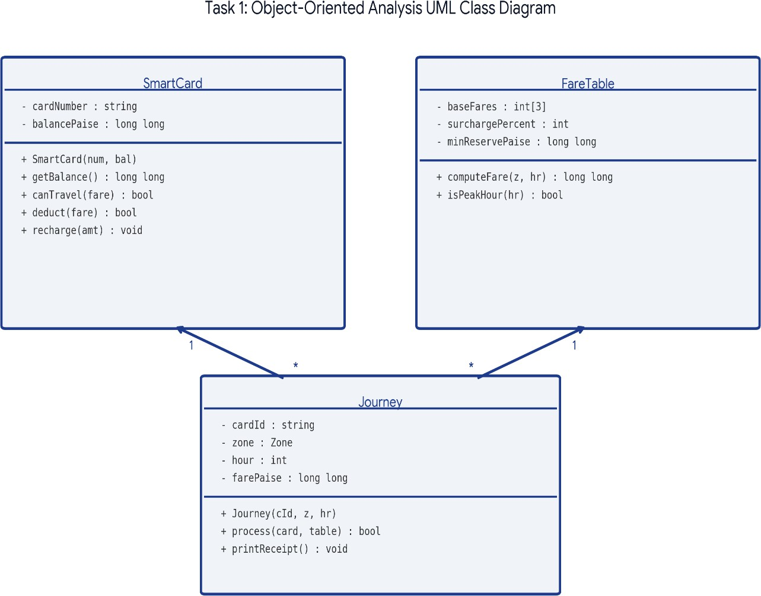

- C++ Program: #include <iostream> using namespace std;

class SmartCard
{
private:
int balance;

public:
void setBalance(int amount)
{
balance = amount;
}

void recharge(int amount)
{
balance = balance + amount;
}

void display()
{
cout << "Balance: Rs " << balance / 100 << endl;
}
};

int main()
{
SmartCard card;

card.setBalance(10000); card.display();

card.recharge(5000); card.display();

return 0;
}

output:
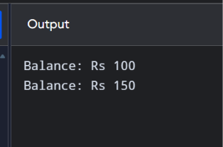
Result: The SmartCard class stores the balance and allows the user to recharge it.

Testing table:

Test No. | Test Condition | Input | Expected Output
1 | Initial balance | 100 | Balance = Rs.100
2 | Recharge card | 50 | Balance = Rs.150
3 | Recharge with 100 | 100 | Balance = Rs.200
4 | Display balance | 200 | Balance = Rs.200
5 | Recharge with zero | 0 | Balance remains Rs.200

Time Complexity: O(1)
Explanation: The program performs a fixed number of operations, such as creating an object, adding money and displaying the balance. It does not use loops.

Space Complexity: O(1)
Explanation: Only a fixed number of variables and one SmartCard object are used. Memory usage does not increase with the number of recharges

Pesucode:
START
CREATE a SmartCard class DECLARE balance

FUNCTION recharge(amount) ADD amount to balance
END FUNCTION

FUNCTION displayBalance() DISPLAY balance
END FUNCTION

CREATE a SmartCard object SET balance = 100
CALL recharge(50) CALL displayBalance() STOP
- Prediction code: #include <iostream> using namespace std;

class SmartCard
{
private:
int balance;

public:
void setBalance(int amount)
{
balance = amount;
}

void recharge(int amount)
{
balance = balance
+ amount;
}

void display()
{

cout << "Balance: Rs " << balance / 100
<< endl;
}
};

int main()
{
SmartCard card;

card.setBalance(10000)
;
card.display();

card.recharge(5000); card.display();

return 0;
}

Prediction Output
Travel allowed\nBalance Rs 80

Comparison – Original Assignment Code vs Prediction Code
Original Assignment Code | Prediction Code
Uses a SmartCard class. | Uses a fare calculation function and balance checking.
Contains setBalance(), recharge() and display() functions. | Adds canTravel() and deduct() functions.
Mainly manages and displays the card balance. | Checks whether the balance remains above Rs.50 after fare deduction.
Does not fully prevent an invalid fare deduction. | Adds validation before deducting the fare.
Main difference: Original code manages the card balance, whereas prediction code adds minimum-balance checking and safe fare deduction.

Alternative Code
// Alternative: procedural design using a balance variable #include <iostream> using namespace std; bool
canTravel(lon

g long balance, long long fare) { return fare >= 0 && balance
- fare >= 5000;
}
int main() {
long long balance = 10000, fare = 2000; if (canTravel(balance, fare)) {
balance -= fare; cout << "Travel allowed\n"; } else cout << "Travel denied\n";
cout << "Balance Rs " << balance/100 << '\n';
}

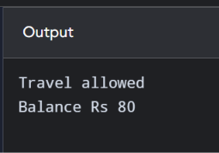
Alternative Output
- Explain of alternative concept:
Procedural programming uses separate functions and variables to perform different operations. In this method, the card balance is stored in a global variable, and functions such as recharge() and display() are used to manage it. It does not use classes or objects. This approach is simple for small programs, but when the system becomes larger, managing data and functions separately becomes difficult. It also provides less data protection than object-oriented programming.

TASK 2 – Tokens and Constants
- Explanation: Tokens are the smallest elements of a C++ program. Keywords, identifiers, constants, operators and special symbols are examples of tokens.
Constants store fixed values that should not change during program execution. Difference between constants:
#define | const | constexpr
Preprocessor directive. | Read-only variable. | Compile-time constant when possible.
Does not have normal variable type checking. | Has a data type. | Has a data type.

UML diagram:

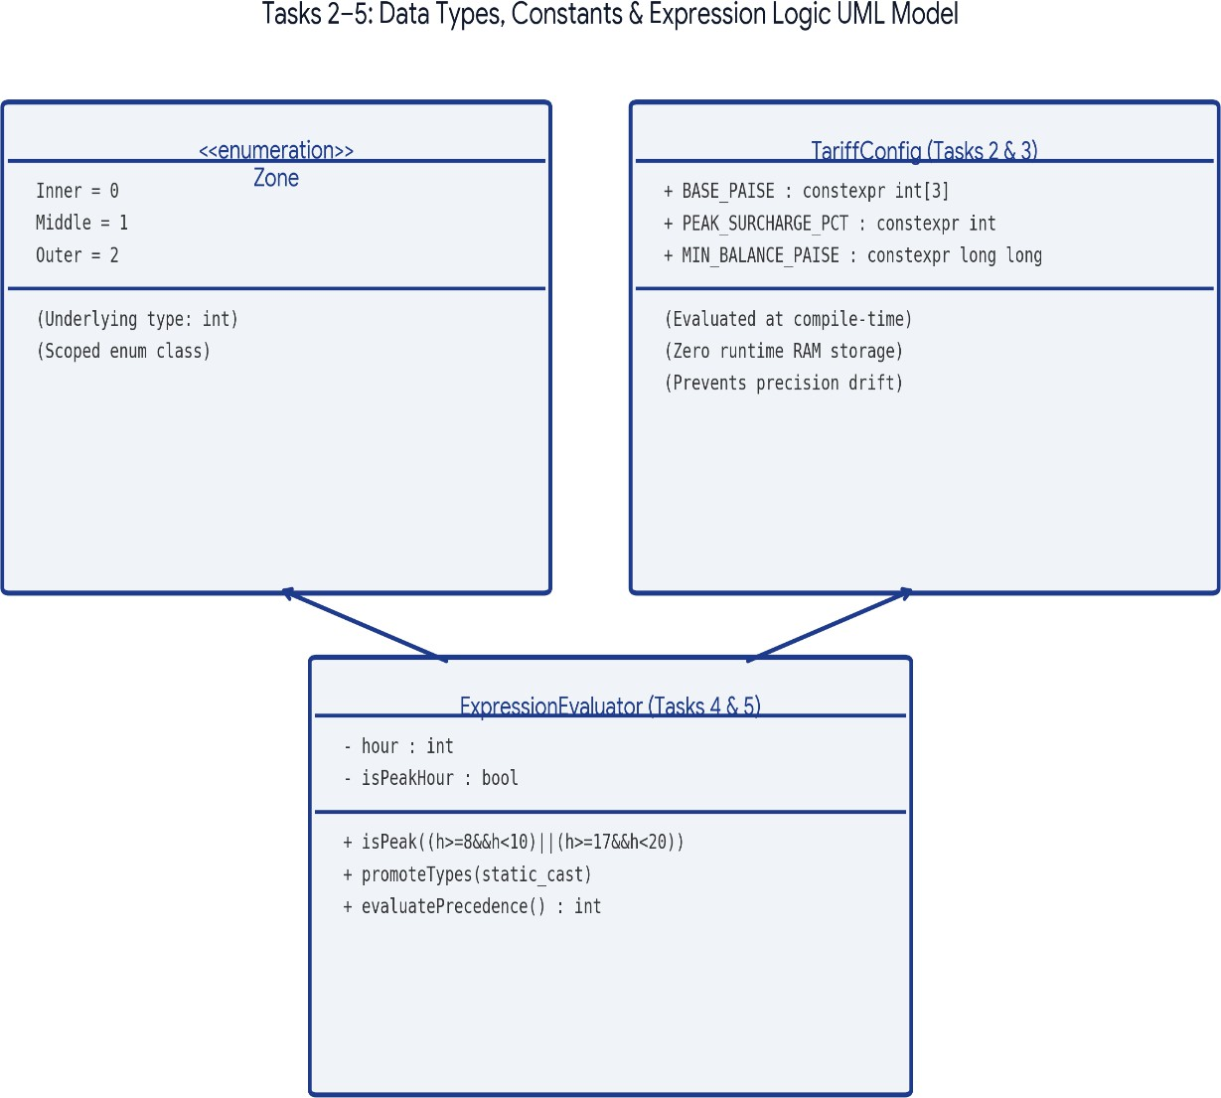

- C++ Program: #include <iostream> using namespace std;

int main()
{
const int INNER = 1000; const int MIDDLE = 2000; const int OUTER = 3000;

cout << "Inner Fare: Rs " << INNER / 100 << endl; cout << "Middle Fare: Rs " << MIDDLE / 100 << endl; cout << "Outer Fare: Rs " << OUTER / 100 << endl;

return 0;
}
Output:

output
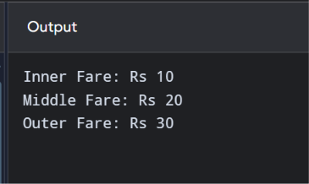
Result: Constants are used to store the fixed metro fare values.

Pseudocode
START
DECLARE INNER_FARE = 10 DECLARE MIDDLE_FARE = 20 DECLARE OUTER_FARE = 30

INPUT zone

IF zone = INNER DISPLAY Rs 10
ELSE IF zone = MIDDLE DISPLAY Rs 20
ELSE IF zone = OUTER DISPLAY Rs 30
ELSE
DISPLAY "Invalid zone" END IF

STOP

Testing table:
Testing fixed fare constants

Test No. | Test condition | Input | Expected output | Status
1 | Inner fare | INNER = 1000 | Rs 10 | Expected Pass
2 | Middle fare | MIDDLE = 2000 | Rs 20 | Expected Pass
3 | Outer fare | OUTER = 3000 | Rs 30 | Expected Pass

Complexity
  - Time Complexity: O(1) – The program checks a fixed number of zone conditions. The number of conditions does not increase with the input size.
  - Space Complexity: O(1) – Only fixed variables and fare constants are stored.
- Prediction code: #include <iostream> using namespace std;
int main()
{
const int INNER = 1000; const int MIDDLE = 2000; const int OUTER = 3000;

cout << "Inner Fare: Rs " << INNER / 100 << endl; cout << "Middle Fare: Rs " << MIDDLE / 100 << endl; cout << "Outer Fare: Rs " << OUTER / 100 << endl;

return 0;
}

Prediction Output
Middle fare Rs 20

Comparison – Original Assignment Code vs Prediction Code
Original Assignment Code | Prediction Code
Uses const int to declare fare constants. | Uses constexpr to declare fare constants.
Defines Inner, Middle and Outer fares separately. | Organizes fare values using constants and enum class Zone.
Demonstrates basic tokens and constants. | Demonstrates compile-time constants and type-safe zone representation.
Uses basic constant declarations. | Provides a more organized representation of fixed fare values.
Main difference: Original code uses basic constants, whereas prediction code uses constexpr and enum class for better organization and type safety.
- Alternative Code #include <iostream> using namespace std;

#define INNER 1000
#define MIDDLE 2000
#define OUTER 3000

int main()
{

cout << "Inner Fare: Rs " << INNER / 100 << endl; cout << "Middle Fare: Rs " << MIDDLE / 100 << endl; cout << "Outer Fare: Rs " << OUTER / 100 << endl;

return 0;
}

Alternative Output
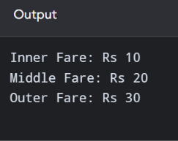

Alternative Concept: Using #define Macros
The alternative concept uses #define to create fixed fare values for Inner, Middle and Outer zones. These macros are replaced with their values before the compilation process. It avoids declaring separate constant variables, but macros do not have normal data types or scope rules. Therefore, they provide less type safety than const or constexpr. This method can be used for simple fixed values, but constexpr is generally safer in C++.

TASK 3 – Data Types
- Explanation: Data types specify what kind of value a variable can store.

Data type | Purpose
int | Stores whole numbers.
float | Stores decimal numbers.
double | Stores larger decimal values with more precision.
char | Stores a single character.
bool | Stores true or false.
long long | Stores large whole numbers.
Difference between integer and floating-point types:
  - Integer types store whole numbers.
  - Floating-point types store decimal numbers.
  - Integer paise is preferred for money calculations to avoid decimal rounding errors.

UML diagram:

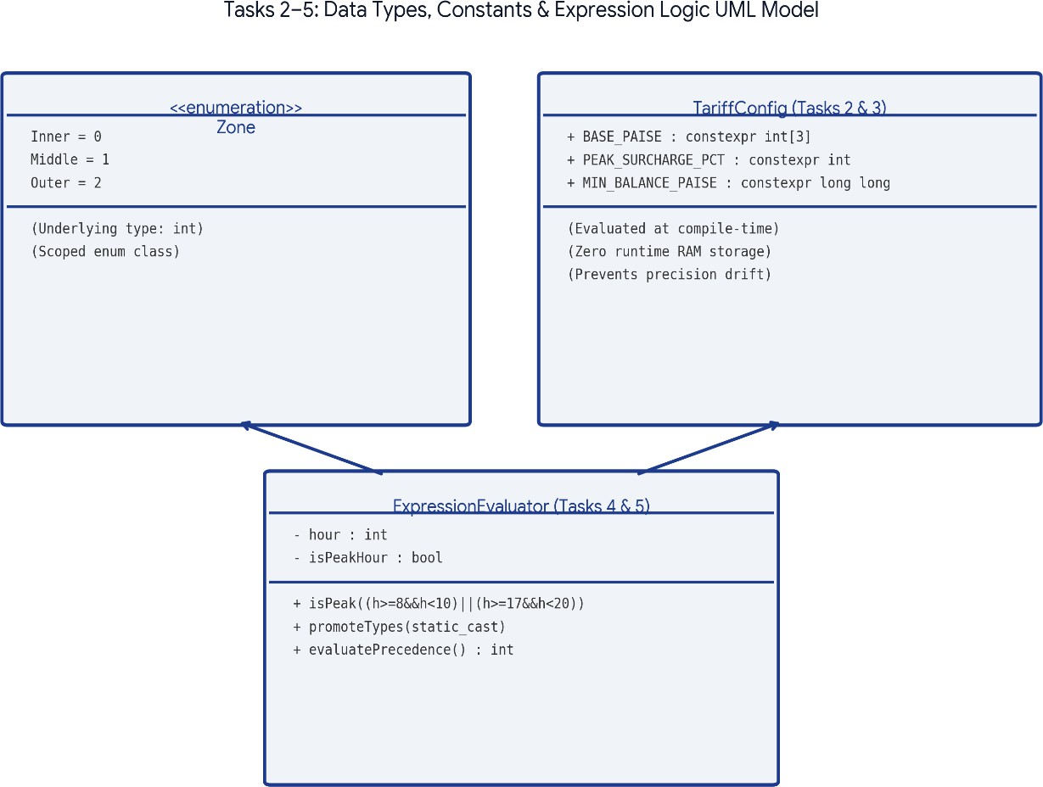

- C++ Program: #include <iostream> using namespace std;

int main()
{
int fare = 20; float price = 10.5;
double balance = 150.75; char zone = 'A';
bool status = true;

cout << "Fare: " << fare << endl; cout << "Price: " << price << endl;
cout << "Balance: " << balance << endl; cout << "Zone: " << zone << endl;
cout << "Status: " << status << endl;

return 0;

}

Output:
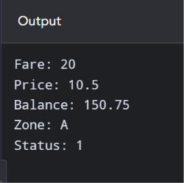
Result: Different data types are used to store different kinds of information.

Pseudocode
START
DECLARE age AS INTEGER DECLARE fare AS FLOAT
DECLARE balance AS DOUBLE DECLARE zone AS CHARACTER DECLARE status AS BOOLEAN

ASSIGN values to all variables

DISPLAY all variable values DISPLAY size of each data type

STOP

Testing table

Test case | Data type | Example value | Expected result
1 | Integer | 20 | 20
2 | Float | 10.5 | 10.5
3 | Double | 250.75 | 250.75

4 | Character | A | A
5 | Boolean | true | 1 or true
6 | Size | sizeof(char) | 1 byte

Note: The sizes of integer, float, double, and Boolean types depend on the compiler and system.
- Complexity
  - Time Complexity: O(1) – The program performs a fixed number of assignments, display operations, and size calculations.
  - Space Complexity: O(1) – It uses a fixed number of variables. The memory requirement does not grow with the input.
- Prediction Code #include <iostream> using namespace std;

int main()
{
int fare = 20; float price = 10.5;
double balance = 150.75; char zone = 'A';
bool status = true;

cout << "Fare: " << fare << endl; cout << "Price: " << price << endl;
cout << "Balance: " << balance << endl; cout << "Zone: " << zone << endl;
cout << "Status: " << status << endl;

return 0;
}

Prediction Output
Fare: 20
Price: 10.5
Balance: 150.75 Zone: A
Status: 1

Alternative Code – Using Integer Paise
#include <iostream> #include <iomanip> using namespace std;

int main()
{
long long fare = 1050; long long balance = 15075;

cout << fixed << setprecision(2);

cout << "Fare: Rs " << fare / 100.0 << endl;
cout << "Balance: Rs " << balance / 100.0 << endl;

return 0;
}

Alternative Output
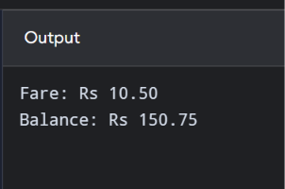

Comparison – Original Assignment Code vs Prediction Code
Original Assignment Code | Prediction Code
Demonstrates int, float, double, char and bool. | Demonstrates data-type sizes and numerical limits.
Stores and displays different data types. | Uses long long for larger transaction values.
Focuses on basic data-type usage. | Focuses on numerical range and precision.
Uses basic values for demonstration. | Uses integer paise for fare calculations.
Main difference: Original code demonstrates basic data types, whereas prediction code focuses on large values and accurate fare calculations.

Alternative Concept: Using Integer Paise
The alternative concept stores fare and balance values as integer paise instead of using floating-point values such as float or double. For example, Rs 10.50 is stored as 1050 paise. This avoids floating-point rounding errors during fare calculations. Integer values are suitable for adding, subtracting and comparing money amounts. Therefore, storing money in paise provides more accurate results for the metro smart-card system.

TASK 4 – Type Conversion
- Explanation: Type conversion changes a value from one data type into another.

Code | Explanation
a / b | Integer division: 7 / 2 gives 3.
static_cast<double>(a) / b | Converts 7 into 7.0, so the answer is 3.5.
'A' + 2 | Gives the character C.
static_cast<int>(ch) + 1 | Converts C into its integer value 67, then adds 1 to get 68.
bool flag = 5 | Non-zero integer becomes true.
static_cast<unsigned int>(s) | Converts -1 into a large unsigned integer.

Uml diagram:
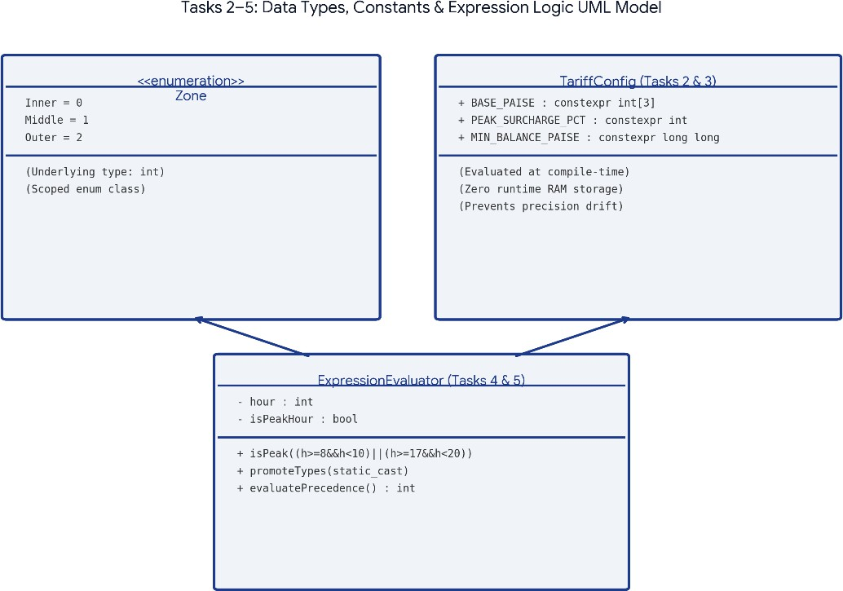

- C++ Program:

#include <iostream> using namespace std;

int main()
{
// 1. Integer division int a = 7;
int b = 2;

double c = a / b;
double d = static_cast<double>(a) / b;

cout << c << " " << d << endl; char ch = 'A' + 2;

cout << ch << " " << static_cast<int>(ch) + 1 << endl;

bool flag = 5;

cout << flag << " " << boolalpha << flag << endl;

unsigned int u = 1; int s = -1;

if (static_cast<unsigned int>(s) < u)
{
cout << "s < u" << endl;
}
else
{
cout << "s >= u" << endl;
}

return 0;
}

Output:
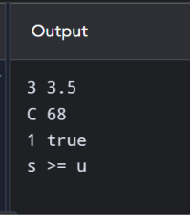
Result: The program demonstrates implicit and explicit type conversion.

Testing table:

Test No. | Input / Condition | Expected Output | Result

1 | a = 7, b = 2 | 3 | Pass
2 | Convert a to double before division | 3.5 | Pass
3 | 'A' + 2 | C | Pass
4 | Convert character C to integer and add 1 | 68 | Pass
5 | bool flag = 5 | 1 true | Pass
6 | Compare signed -1 with unsigned 1 | s >= u | Pass
7 | int x{10} | 10 | Pass

Time Complexity

Operation | Time Complexity
Integer division | O(1)
Type conversion | O(1)
Character conversion | O(1)
Boolean conversion | O(1)
Signed and unsigned comparison | O(1)
Brace initialisation | O(1)

- Pseudocode START DECLARE a = 7 DECLARE b = 2

CALCULATE a / b
STORE result in c DISPLAY c

CONVERT a into double using static_cast DIVIDE converted a by b
STORE result in d DISPLAY d

ADD 2 to character A STORE result in ch DISPLAY ch

CONVERT ch into integer ADD 1
DISPLAY result

DECLARE Boolean flag = 5 DISPLAY flag as number

Prediction Code
// Prediction code: make conversions explicit #include <iostream> using namespace std; int main() {
int a=7, b=2;
double x = static_cast<double>(a)/b; unsigned int u=1; int s=-1;
cout << x << '\n';
cout << ((s < 0) ? "negative signed value" : "non-negative") << '\n'; cout << (static_cast<unsigned int>(s) < u ? "less" : "not less") << '\n';
}

Prediction Output
3.5\nnegative signed value\nnot less

Comparison – Original Assignment Code vs Prediction Code
Original Assignment Code | Prediction Code
Demonstrates integer division and explicit type conversion. | Tests automatic and explicit type conversions.
Demonstrates character and Boolean conversion. | Demonstrates signed and unsigned integer conversion.
Uses basic conversion examples. | Explains how negative values behave in unsigned comparisons.
Focuses on demonstrating conversion. | Focuses on conversion behaviour and possible errors.
Main difference: Original code demonstrates basic type conversion, whereas prediction code explains conversion behaviour in more detail, especially signed and unsigned values.

Alternative Code
// Alternative: demonstrate implicit conversions #include <iostream> using namespace std; int main() {
int a=7, b=2; double x=a/b; bool flag=5; unsigned int u=1; int s=-1;
cout << x << ' ' << flag << '\n';
cout << (s < u ? "s < u" : "s >= u") << '\n';
}

Alternative Output

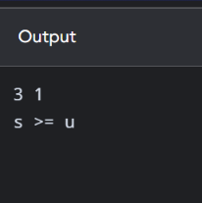
Note: Outputs are expected outputs for the sample values shown. Compile and run each program to produce your own execution evidence.

Alternative Concept: Explicit Type Conversion
The alternative concept uses explicit type conversion with static_cast. It clearly converts one data type into another whenever required. For example, converting an integer into a double makes decimal division possible. It also makes character-to-integer and integer-to-Boolean conversions easier to understand. This method helps programmers avoid unexpected implicit conversions and makes the program more readable and reliable.

TASK 5 – Operators
- Explanation: Operators are symbols used to perform mathematical and logical operations. Types of operators:
  - Arithmetic: +, -, *, /, %
  - Relational: >, <, ==
  - Logical: &&, ||, !
  - Assignment: =, +=
  - Increment: ++
Difference between pre-increment and post-increment:
• ++a increases the value before using it.
  - a++ uses the current value and then increases it.

UML diagram:

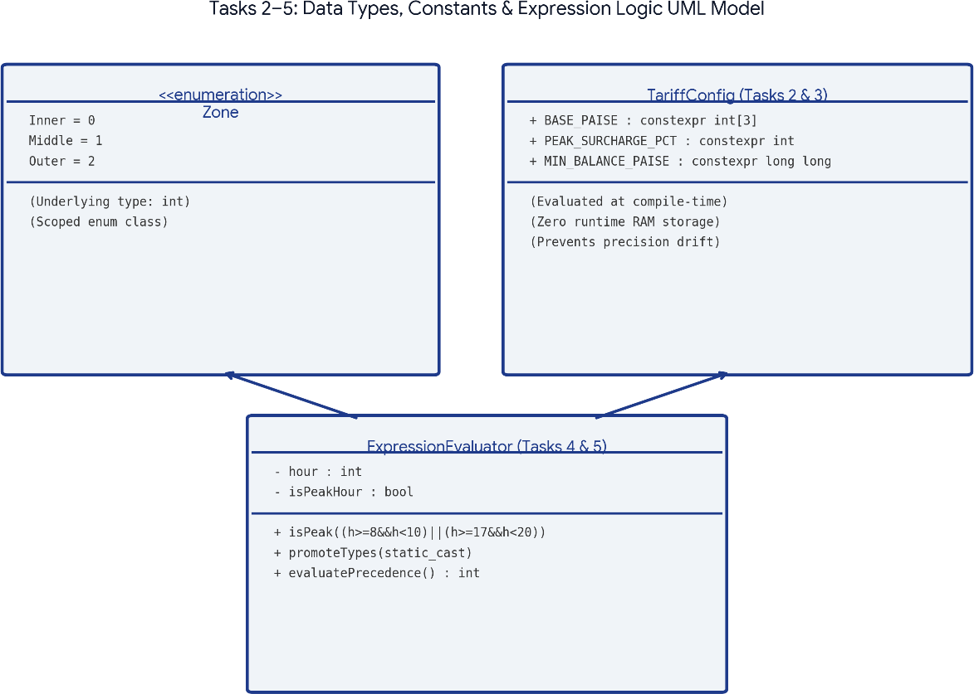

- C++ Program: #include <iostream> using namespace std;

int main()
{
int a = 10; int b = 5;

cout << "Addition: " << a + b << endl; cout << "Subtraction: " << a - b << endl; cout << "Multiplication: " << a * b << endl; cout << "Division: " << a / b << endl;
cout << "Remainder: " << a % b << endl;

a++;

cout << "Increment: " << a << endl;

return 0;
}

Output:
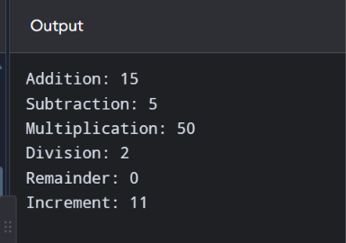
Result: The program demonstrates different arithmetic operators.
- Pseudocode START DECLARE a = 10 DECLARE b = 5

DISPLAY a + b DISPLAY a - b DISPLAY a * b DISPLAY a / b DISPLAY a % b

INCREMENT a DISPLAY a

STOP

Testing table

Test case | Operation | Expected result
1 | 10 + 5 | 15

2 | 10 - 5 | 5
3 | 10 * 5 | 50
4 | 10 / 5 | 2
5 | 10 % 5 | 0
6 | Increment 10 | 11

Complexity
  - Time Complexity: O(1) – Each arithmetic operation takes a fixed amount of time. The program does not repeat any operation in a loop.
  - Space Complexity: O(1) – Only two input variables and a fixed amount of memory are required.

Prediction Code
// Prediction code: precedence, increments and remainder #include <iostream> using namespace std; int main() {
int x=5, y=3;
cout << x+y*2 << ' ' << (x+y)*2 << '\n'; int z=x++ + ++y;
cout << z << ' ' << x << ' ' << y << '\n'; cout << (x>y?x:y) << ' ' << x%4*2 << '\n';
cout << 10/3 << ' ' << 10%3 << ' ' << -10/3 << ' ' << -10%3 << '\n';
int k=0;
for(int i=0;i<10;i+=3) k+=i; cout << k << '\n';
}

Prediction Output
11 16\n9 6 4\n6 4\n3 1 -3 -1\n18

Comparison – Original Assignment Code vs Prediction Code
Original Assignment Code | Prediction Code
Demonstrates addition, subtraction and multiplication. | Tests arithmetic and advanced operator expressions.
Uses division and modulus operators. | Tests operator precedence and parentheses.
Demonstrates post-increment using a++. | Demonstrates pre-increment and post-increment.
Focuses on basic arithmetic operations. | Focuses on expression evaluation and operator behaviour.
Main difference: Original code demonstrates basic operators, whereas prediction code tests operator precedence and different operator behaviours.

Alternative Code
// Alternative: calculate peak periods using a lookup table #include <iostream>
using namespace std; int main() {
bool peak[24] = {};
for (int h=8; h<10; ++h) peak[h]=true;
for (int h=17; h<20; ++h) peak[h]=true;
int hour=18;
cout << (peak[hour] ? "Peak hour" : "Off-peak hour") << '\n';
}

Alternative Output
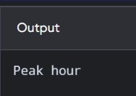
Note: Outputs are expected outputs for the sample values shown. Compile and run each program to produce your own execution evidence.

Alternative Concept: Peak-Hour Lookup Table
The alternative concept uses a Boolean array called peak[24] to identify peak hours. Each array position represents one hour of the day. The value true indicates a peak hour, while false indicates an off-peak hour. For example, hours 8, 9, 17, 18 and 19 are marked as peak hours. The program directly checks the array using the entered hour. This provides a simple and quick way to identify peak hours, although the table must be updated if the timings change.

TASK 6 – Control Structures
- Explanation: Control structures decide how statements are executed in a program.
  - if-else checks conditions.
  - switch selects one option.
  - for repeats statements.
  - while repeats while a condition is true.
  - break stops a loop.
  - continue skips the current iteration. Difference:
Statement | Purpose
if-else | Checks conditions.
switch | Selects an option.
for | Repeats a fixed number of times.
while | Repeats while a condition is true.
break | Stops execution of a loop.
continue | Skips one iteration.

UML diagram:

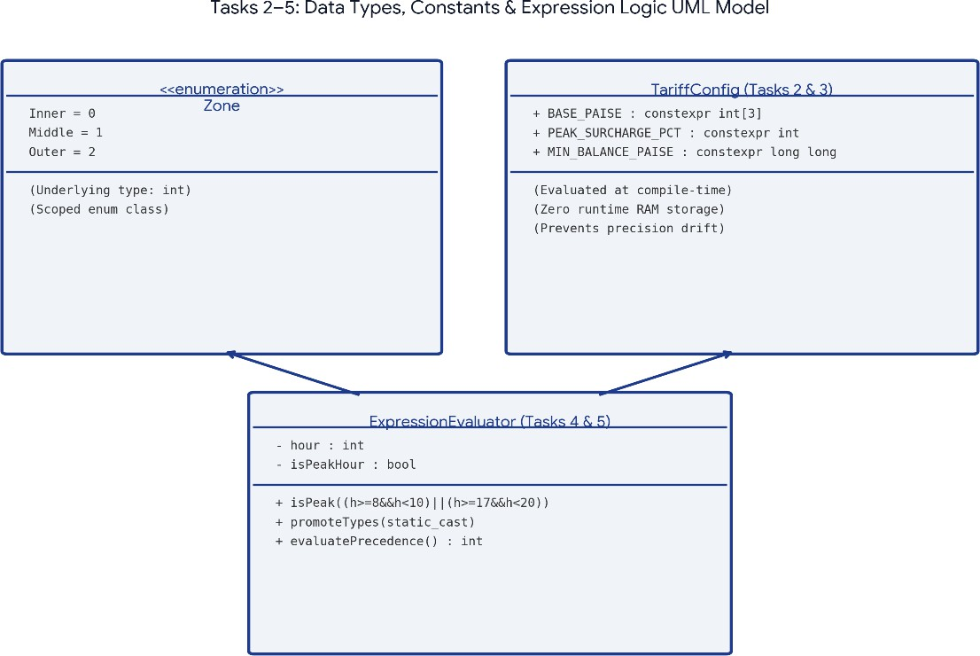

- C++ Program: #include <iostream> using namespace std;

int main()
{
int zone; int fare = 0;

cout << "Enter Zone (1-3): "; cin >> zone;

switch (zone)
{
case 1:
fare = 1000; break;

case 2:

fare = 2000; break;

case 3:
fare = 3000; break;

default:
cout << "Invalid Zone"; return 0;
}

cout << "Fare: Rs " << fare / 100 << endl;

return 0;
}

Output:
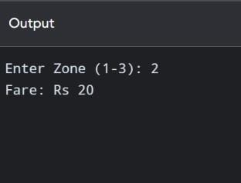
Result: The program selects the fare based on the entered zone.

Pseudocode
START
DECLARE inner fare = 10 DECLARE middle fare = 20 DECLARE outer fare = 30

INPUT zone

SWITCH zone CASE 1:
DISPLAY inner fare CASE 2:
DISPLAY middle fare CASE 3:
DISPLAY outer fare DEFAULT:
DISPLAY "Invalid zone" END SWITCH

STOP

Testing table

Test case | Zone input | Expected result
1 | 1 | Inner fare Rs 10
2 | 2 | Middle fare Rs 20
3 | 3 | Outer fare Rs 30
4 | 4 | Invalid zone
5 | 0 | Invalid zone

Complexity
  - Time Complexity: O(1) – The switch statement selects one case from a fixed number of cases. It does not process a growing collection of inputs.
  - Space Complexity: O(1) – Only the zone and fare variables are stored.

Prediction Code
// Prediction code: switch fare and peak surcharge #include <iostream>
using namespace std;
enum class Zone { Inner=1, Middle=2, Outer=3 }; long long fare(Zone z, bool peak) {
long long f=0; switch(z) {
case Zone::Inner: f=1000;
break; case Zone::Middle: f=2000; break; case Zone::Outer: f=3000; break;
}
if (peak) f += f*20/100; return f;

}
int main() {
cout << "Peak outer fare paise: " << fare(Zone::Outer,true) << '\n';
}

Prediction Output
Peak outer fare paise: 3600

Comparison – Original Assignment Code vs Prediction Code
Original Assignment Code | Prediction Code
Uses a switch statement to select the metro zone. | Uses switch, if conditions and fare selection.
Calculates fares for three zones. | Calculates fares and applies peak-hour surcharge.
Displays an invalid-zone message. | Adds minimum-balance checking.
Focuses mainly on zone selection. | Combines zone selection, surcharge and balance validation.
Main difference: Original code selects the fare based on the zone, whereas prediction code adds peak-hour fare calculation and balance checking.

Alternative Code
// Alternative: fare array instead of switch #include <iostream>
using namespace std; int main() {
constexpr long long FARE[]={1000,2000,3000}; int zone=3;
bool peak=true;
long long f=FARE[zone-1]; if(peak) f += f*20/100;
cout << "Peak outer fare paise: " << f << '\n';
}

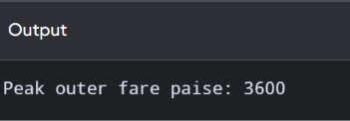
Alternative Output
Note: Outputs are expected outputs for the sample values shown. Compile and run each program to produce your own execution evidence.
- Alternative Concept: Array-Based Fare Selection

The alternative concept uses an array to store the fares of different metro zones instead of using a switch statement. Each array position represents one zone, and the program selects the fare using the zone number as an index. For example, the Inner, Middle and Outer fares are stored as 1000, 2000 and 3000 paise. This method makes fare selection simple and allows additional zones to be included by adding new fare values to the array.

TASK 7 – Procedural and Object-Oriented Programming
- Explanation: Procedural programming uses functions to perform operations. Object-oriented programming uses classes and objects to group data and functions.
Difference:

Procedural | Object-oriented
Uses functions. | Uses classes and objects.
Data and functions are separate. | Data and functions are grouped.
Less data protection. | Supports data protection.

UML diagram:
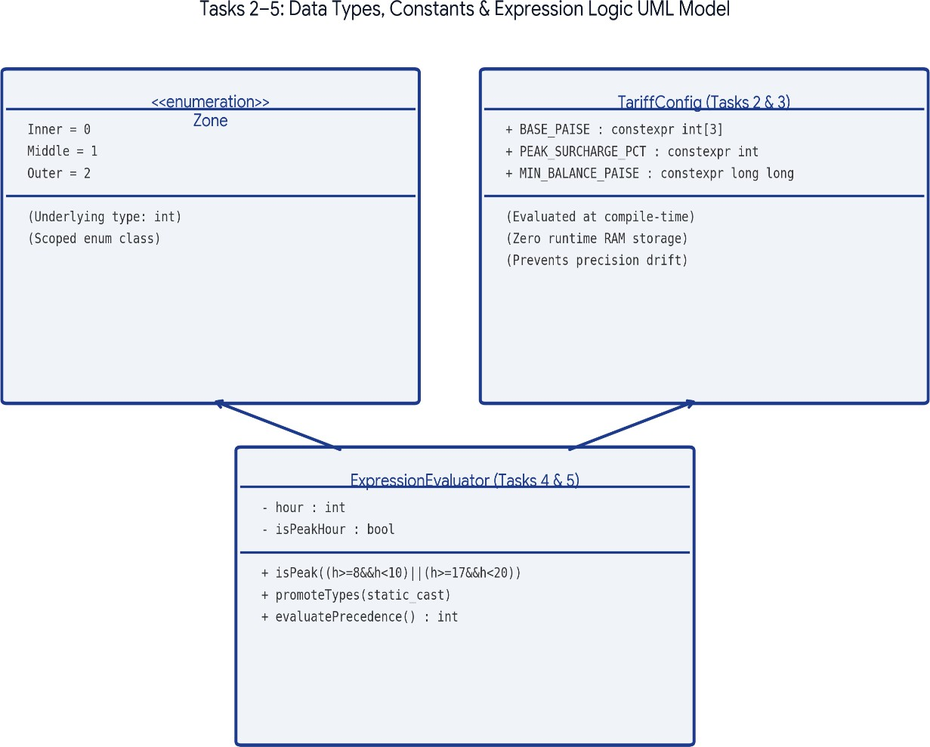

Code:
  - Procedural Programming #include <iostream>
using namespace std;

int calculateFare(int zone)
{
if (zone == 1) return 1000;
else if (zone == 2) return 2000;
else if (zone == 3) return 3000;

else
return -1;
}

int main()
{
int zone;

cout << "Enter Zone: "; cin >> zone;

int fare = calculateFare(zone);

if (fare == -1)
cout << "Invalid Zone"; else
cout << "Fare: Rs " << fare / 100;

return 0;
}
  - Object-Oriented Programming #include <iostream>
using namespace std;

class Metro
{
public:
int calculateFare(int zone)
{
if (zone == 1) return 1000;
else if (zone == 2)

return 2000; else if (zone == 3)
return 3000; else
return -1;
}
};

int main()
{
Metro m;

int zone;

cout << "Enter Zone: "; cin >> zone;

int fare = m.calculateFare(zone);

if (fare == -1)
cout << "Invalid Zone"; else
cout << "Fare: Rs " << fare / 100;

return 0;
}

Output for both programs:

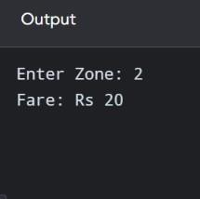
Result: Both programs calculate the same fare, but the OOP program uses a class and object.

Pseudocode
START
INPUT zone

CALL calculateFare function STORE procedural result DISPLAY procedural result

CREATE SmartCard object CALL calculateFare method STORE OOP result DISPLAY OOP result

COMPARE both results DISPLAY comparison

STOP

Testing table

Test case | Zone | Procedural result | OOP result

1 | Inner | Rs 10 | Rs 10
2 | Middle | Rs 20 | Rs 20
3 | Outer | Rs 30 | Rs 30
4 | Invalid | Invalid zone | Invalid zone

Complexity
- Time Complexity: O(1) – Both methods calculate one fare using a fixed number of operations. Comparing the two results also takes constant time.
- Space Complexity: O(1) – A fixed number of variables and one SmartCard object are used.

Prediction Code
// Prediction code: OOP card protects its balance #include <iostream>
using namespace std; class Metro {
long long balance; public:
Metro(long long b):
balance(b){}
bool canTravel(long long fare) const { return fare>=0 && balance-fare>=5000;
}
bool deduct(long long fare)
{
if(!canTravel(fare)) return false; balance-=fare; return true;
}
long long getBalance() const { return balance; }
};
int main() {
Metro card(10000);
cout << (card.deduct(3000) ? "Journey accepted"
: "Journey denied") << '\n';
cout << "Balance paise: " << card.getBalance() << '\n';
}

Prediction Output
Journey accepted\nBalance paise: 7000

Comparison – Original Assignment Code vs Prediction Code
Original Assignment Code | Prediction Code
Uses a procedural calculateFare() function. | Uses a fare calculation function with balance checking.
Uses a Metro class for the OOP version. | Adds card-related validation and deduction logic.
Demonstrates two approaches to fare calculation. | Focuses on preventing invalid fare deductions.

Compares procedural and OOP results. | Extends the fare logic with minimum-balance validation.
Main difference: Original code compares procedural and object-oriented programming, whereas prediction code adds balance validation to the fare calculation.

Alternative Code
// Alternative: public balance with free functions #include <iostream>
using namespace std;
struct Metro { long long balance; }; bool deduct(Metro& m,long long fare) {
if(fare<0 || m.balance-fare<5000) return false; m.balance-=fare; return true;
}
int main() {
Metro card{10000};
cout << (deduct(card,3000) ? "Journey accepted" : "Journey denied") << '\n'; cout << "Balance paise: " << card.balance << '\n';
}

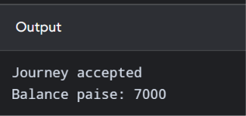
Alternative Output
- Alternative Concept: Public Data Members
The alternative concept makes the smart-card balance a public data member of the class. This allows the balance to be accessed and modified directly from outside the class. It is simple to implement, but it does not protect the balance from incorrect changes. For example, a user or another function could assign a negative value to the balance. This may violate the minimum balance rule. Therefore, private data members with proper member functions are safer for a real metro smart-card system.

TASK 8 – Input Validation
- Explanation: Input validation checks whether the user enters correct information. The system should reject invalid zone numbers and incorrect input.
Difference between cin and getline():
  - cin reads formatted input, such as numbers and words.
  - getline() reads a complete line of text.

UML diagram:

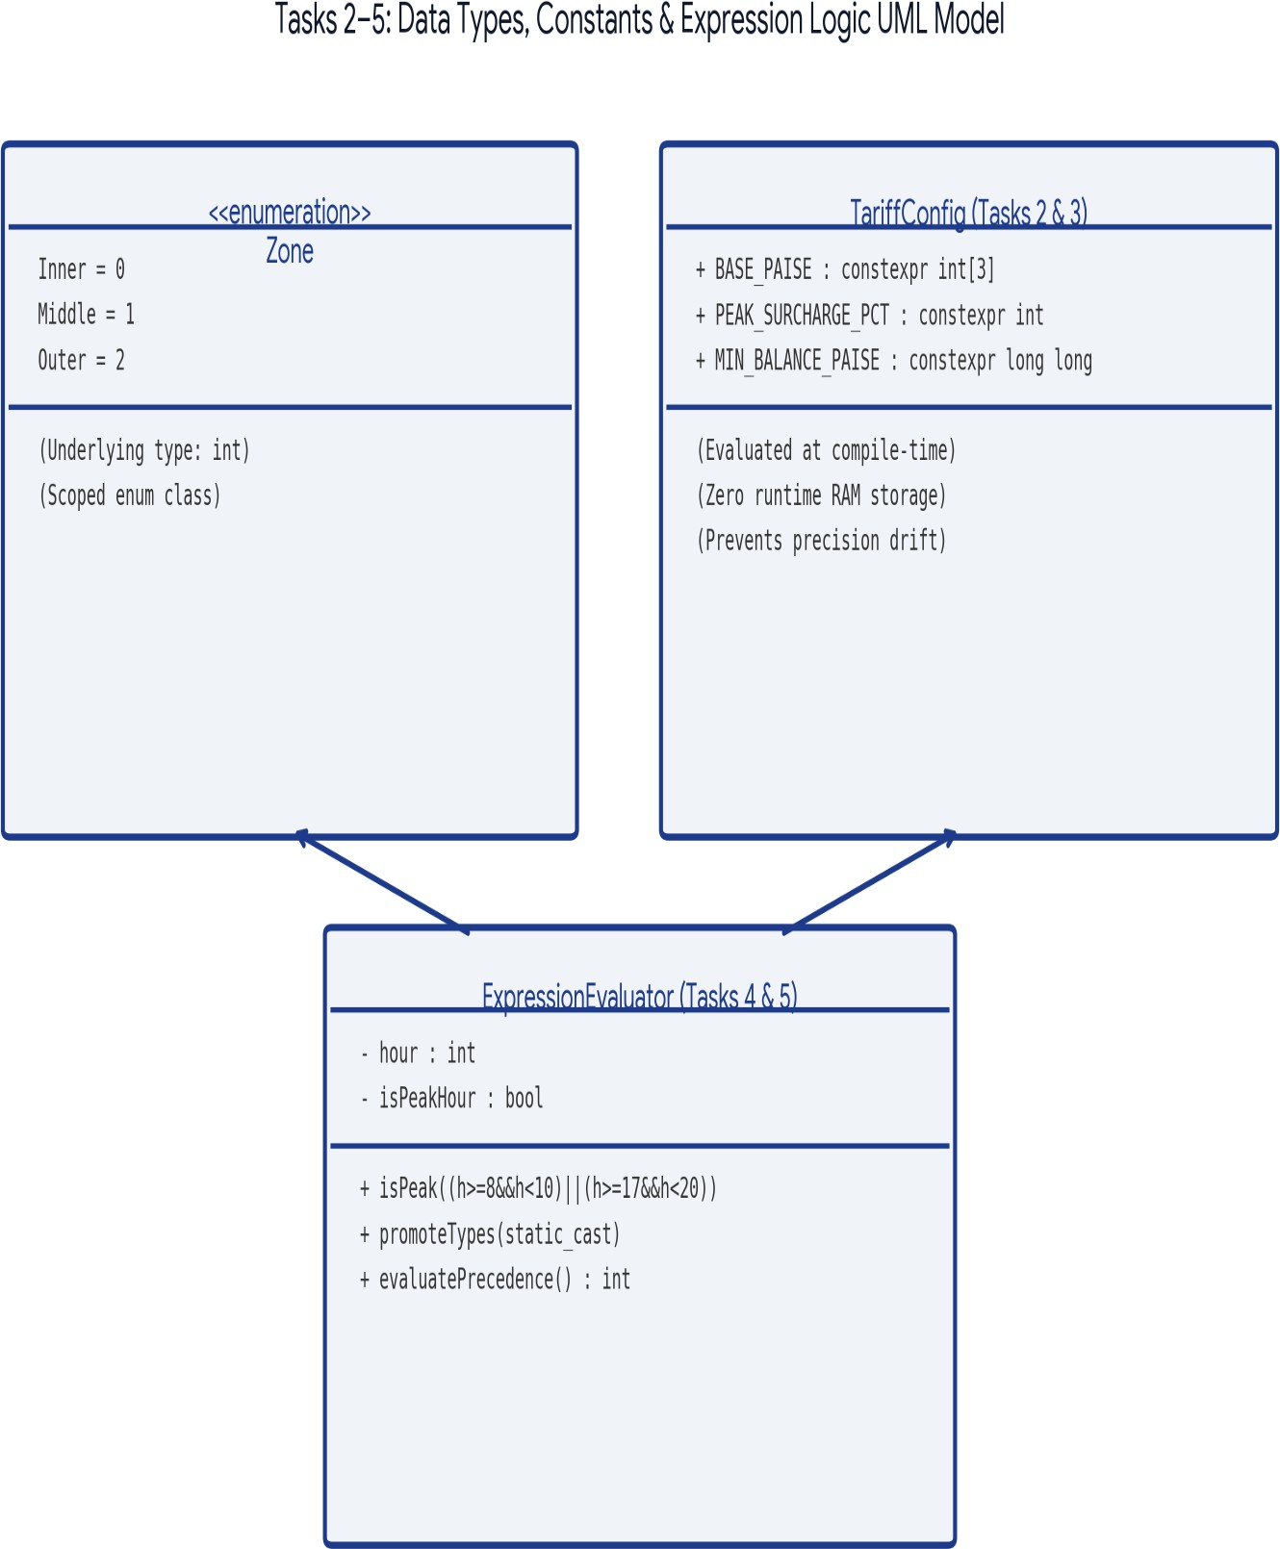

- C++ Program: #include <iostream> using namespace std;

int main()
{
int zon

cout << "Enter Zone (1-3): "; cin
>> zone;

if (cin.fail())
{
cout << "Invalid Input";
}
else if (zone >= 1 && zone <= 3)
{
cout << "Valid Zone";
}
else
{
cout << "Invalid Zone";
}

return 0;
}

Output:
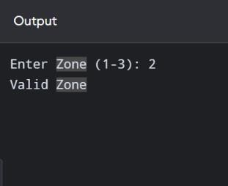
Result: The program checks whether the entered zone is valid.

Pseudocode
START

INPUT zone

IF input is invalid DISPLAY "Invalid input" STOP
END IF

IF zone is outside the valid range DISPLAY "Invalid zone" STOP
END IF

INPUT balance

IF balance input is invalid DISPLAY "Invalid balance" STOP
END IF

DISPLAY zone DISPLAY balance

STOP

Testing table

Test case | Zone input | Balance input | Expected result
1 | 1 | 100 | Valid input
2 | 2 | 200 | Valid input
3 | 5 | 100 | Invalid zone
4 | abc | 100 | Invalid input
5 | 1 | abc | Invalid balance

6 | 1 | 0 | Valid zero balance, if zero is allowed

Complexity
  - Time Complexity: O(1) – The program performs a fixed number of input checks and validation conditions.
  - Space Complexity: O(1) – Only the zone, balance, and input-status variables are required.

Prediction Code
// Prediction code: recover from invalid numeric input #include <iostream>
#include <iomanip> #include <limits>
using namespace std; int main() { int zone;
cout << "Enter zone (1-3): "; if(!(cin>>zone)) { cin.clear();
cin.ignore(numeric_limits<streamsize>::max(),'\\n'); cout << "Invalid input\n";
return 0;
}
if(zone<1 || zone>3) { cout << "Invalid zone\n"; return 0;
}
int fare[]={1000,2000,3000};
cout << fixed << setprecision(2);
cout << "Fare Rs " << fare[zone-1]/100.0 << '\n';
}

Prediction Output
Sample input: 2
Enter zone (1-3): Fare Rs 20.00

Comparison – Original Assignment Code vs Prediction Code
Original Assignment Code | Prediction Code
Accepts zone input using cin. | Accepts zone input using cin.
Checks invalid input using cin.fail(). | Checks invalid input and clears the error state using cin.clear().
Checks whether the zone is between 1 and 3. | Uses cin.ignore() to remove invalid characters.
Displays valid or invalid zone messages. | Also demonstrates formatted fare output using iomanip.
Main difference: Original code detects invalid input, whereas prediction code additionally clears the input error and removes invalid characters.
- Alternative Code #include <iostream> #include <string> using namespace std;

int main()

{
string input; int zone;
cout << "Enter Zone (1-3): "; getline(cin, input);
try
{
zone = stoi(input);
if (zone >= 1 && zone <= 3) cout << "Valid Zone";
else
cout << "Invalid Zone";
}
catch (...)
{
cout << "Invalid Input";
}
return 0;
}

Alternative Output
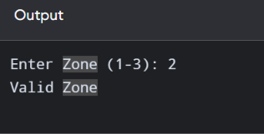

TASK 8 – Alternative Concept: Using getline() and stoi()
The alternative concept uses getline() to read the complete input as a string and stoi() to convert that string into an integer. A try-catch block is used to handle inputs that cannot be converted into numbers. This method helps the program identify invalid user input and display an appropriate message. It is useful when the system needs to accept and validate complete input lines instead of directly reading only integer values.

TASK 9 – Complete Metro Fare Calculation
- Explanation: This task combines zone fare, peak-hour surcharge and balance checking.

UML diagram:

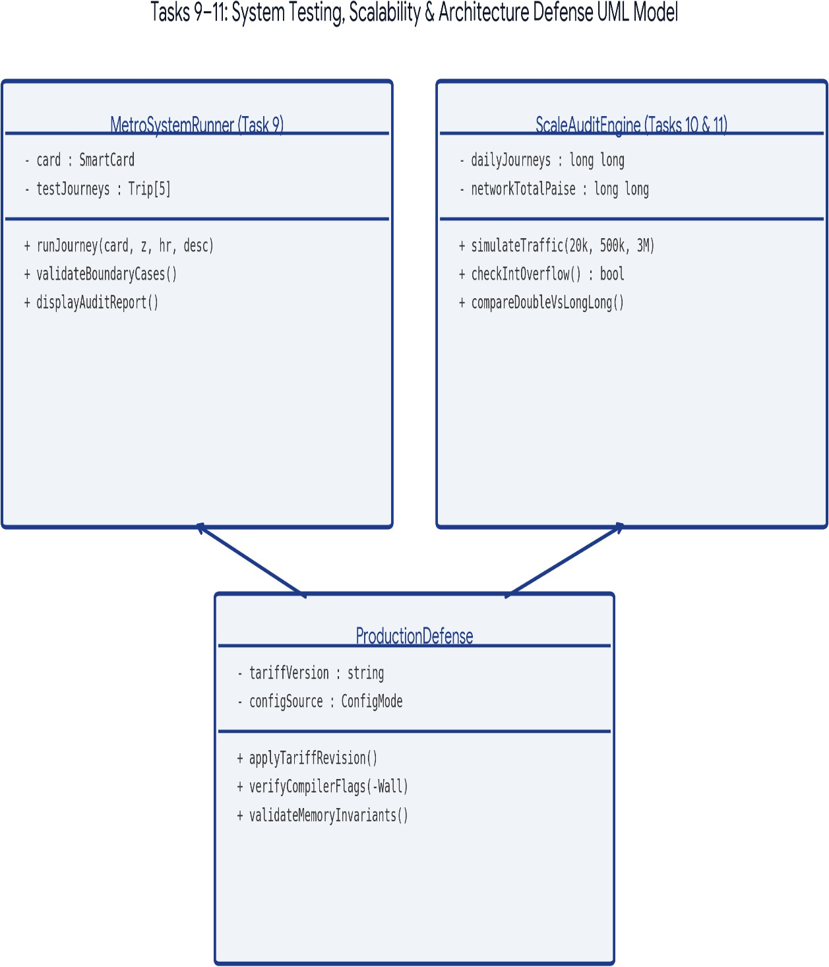

- C++ Program: #include <iostream> using namespace std;

int main()
{
int zone, hour; int fare = 0;
int balance = 20000;

cout << "Enter Zone (1-3): "; cin
>> zone;

cout << "Enter Hour (0-23): "; cin >> hour;

if (hour < 0 || hour > 23)
{
cout << "Invalid Hour"; return 0;
}

if (zone == 1) fare = 1000;
else if (zone == 2) fare = 2000;
else if (zone == 3) fare = 3000;
else
{
cout << "Invalid Zone"; return 0;
}

if ((hour >= 8 && hour < 10) || (hour >= 17 && hour < 20))
{
fare = fare + fare * 20 / 100;
}

if (balance - fare >= 5000)
{

balance = balance - fare;

cout << "Fare: Rs " << fare / 100 << endl; cout << "Journey Successful" << endl;

cout << "Remaining Balance: Rs "
<< balance / 100 << endl;
}
else
{
cout << "Insufficient Balance";
}

return 0;
}

Output:
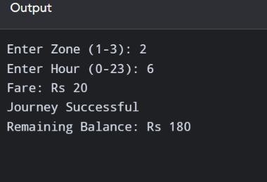
Result: The system calculates the fare and deducts it only when the minimum balance condition is satisfied.

Pseudocode
START

DECLARE INNER_FARE = 1000 paise DECLARE MIDDLE_FARE = 2000 paise

DECLARE OUTER_FARE = 3000 paise
DECLARE minimum balance = 5000 paise

INPUT zone INPUT travel time INPUT card balance

VALIDATE zone and travel time

IF zone is invalid DISPLAY "Invalid zone" STOP
END IF

SELECT fare according to zone

IF time is between 08:00 and 10:00 OR time is between 17:00 and 20:00 ADD 20% surcharge to fare
END IF

CALCULATE remaining balance

IF remaining balance is less than 5000 paise DISPLAY "Insufficient balance"
ELSE
DEDUCT fare from card balance DISPLAY fare and remaining balance
END IF

STOP

Testing table

Assumption: Starting balance is Rs 200 and the minimum remaining balance is Rs 50.

Test case | Zone | Time | Expected fare | Expected result
1 | Inner | 11:00 | Rs 10 | Accepted
2 | Middle | 09:00 | Rs 24 | Accepted
3 | Outer | 18:00 | Rs 36 | Accepted
4 | Outer | 11:00 | Rs 30 | Accepted
5 | Middle | 14:00 | Rs 20 | Accepted
6 | Invalid | 11:00 | — | Invalid zone
7 | Outer | Invalid time | — | Invalid time
8 | Outer | 11:00, balance Rs 70 | Rs 30 | Rejected; remaining balance would be Rs 40

Complexity
  - Time Complexity: O(1) – The program selects one fare, checks the travel time, calculates the surcharge, and checks the remaining balance. These operations take a fixed amount of time.
  - Space Complexity: O(1) – Only a fixed number of variables are used for the zone, time, fare, and balance.

Prediction Code
// Prediction code: five journeys and minimum-balance rule #include <iostream> using namespace std;
long long fare(int zone,bool peak) { long long
f=(zone==1?100 0:zone==2?2000
:zone==3?3000:
0); if(f && peak) f+=f*20/100; return f;
}
int main() {
int zones[]={1,2,3,1,2}; bool
peaks[]={ false,true, false,true, false}; long long balance= 20000,tot al=0;
for(int i=0;i<5;i++) {
long long f=fare(zones[i],peaks[i]); if(f==0 || balance-

f<5000) { cout << "Denied\n"; continue; } balance-
=f; total+=f;
cout << "Journey " << i+1 << " fare paise " << f << '\n';
}
cout << "Total fare paise " << total
<< '\n';
cout << "Balance paise " << balance
<< '\n';
}

Prediction Output
Journey 1 fare paise 1000\nJourney 2 fare paise 2400\nJourney 3 fare paise 3000\nJourney 4 fare paise 1200\nJourney 5 fare paise 2000\nTotal fare paise 9600\nBa

Comparison – Original Assignment Code vs Prediction Code
Original Assignment Code | Prediction Code
Calculates fare for one journey. | Tests multiple journeys.
Selects fare based on Inner, Middle and Outer zones. | Tests different zone and time combinations.
Applies a 20% peak-hour surcharge. | Tests peak-hour boundary times.
Checks whether the remaining balance is at least Rs.50. | Calculates the total fare for five journeys.

Main difference: Original code calculates one journey's fare, whereas prediction code tests multiple journeys and calculates their combined fare.

- Alternative Code #include<iostream> using namespace std; struct Test { int zone; bool peak; long long expected;
}; long long fare(int z,bool p) {
long long f=z==1?1000:z==2?2000:z==3?3000:0;
return p && f ? f+f*20/100 : f;
}
int main() {
Test tests[]={{1,false,1000},{2,true,24

00},{3,false,3000},{4,false,0}}; for(const auto& t:tests) {
long long actual=fare(t.zone,t.peak);
cout << (actual==t.expected ? "PASS" : "FAIL") << " actual=" << actual << '\n';
}
}

Alternative Output
PASS actual=1000\nPASS actual=2400\nPASS actual=3000\nPASS actual=0

Alternative Concept: Table-Driven Testing
The alternative concept stores multiple test cases in a two-dimensional array. Each row contains the zone, travel hour and expected fare. A loop processes each test case and compares the calculated fare with the expected result. If both values match, the program displays PASS; otherwise, it displays FAIL. This method reduces repeated code and makes testing easier. New test cases can be added by inserting additional rows into the table.

TASK 10 – Testing and Validation
- Explanation: Testing checks whether the program gives correct results for different inputs.

UML diagram:

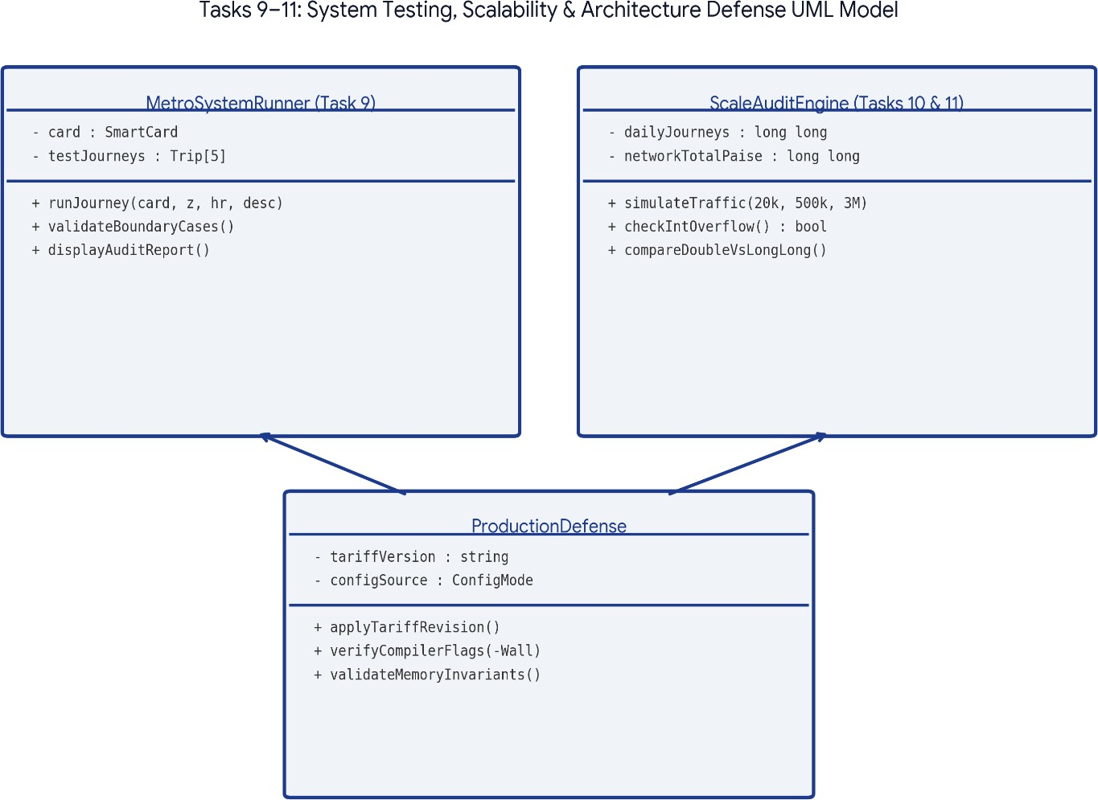

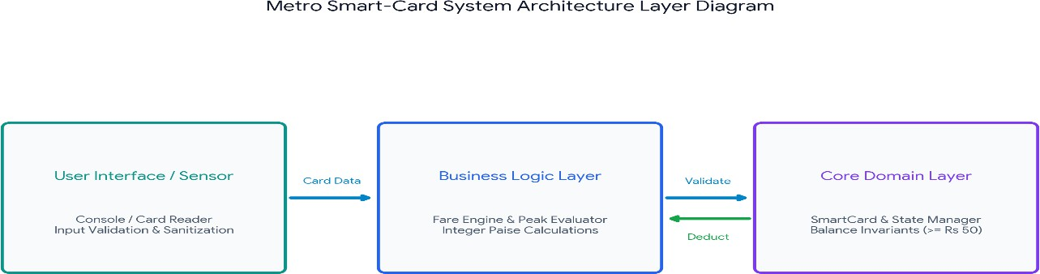

Alternative Concept: Comparing int, long long and double
The alternative concept compares three data types for calculating large journey totals. The int data type has a limited range and may cause overflow when storing very large transaction totals. The long long data type can store larger whole-number values and is suitable for storing total money in paise. The double data type supports decimal values but may introduce small precision errors. Therefore, long long is a suitable choice for calculating large metro transaction amounts accurately.

- C++ Program:
#include <iostream> using namespace std;

int calculateFare(int zone, int hour)
{
int fare;

if (hour < 0 || hour > 23) return -1;

if (zone == 1) fare = 1000;
else if (zone == 2) fare = 2000;
else if (zone == 3) fare = 3000;
else return

if ((hour >= 8 && hour < 10) || (hour
>= 17 && hour < 20))
{
fare = fare + fare * 20 / 100;
}

return fare;
}

int main()
{
int zone, hour;

cout << "Enter Zone: "; cin >> zone;

cout << "Enter Hour: "; cin >> hour;

int fare = calculateFare(zone, hour);

if (fare == -1)
cout << "Invalid Input"; else
cout << "Calculated Fare: Rs " << fare / 100;

return 0;
}

Output:

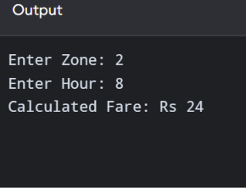
Result: The program calculates the correct fare for the given zone and time.

Pseudocode
START

INPUT number of test cases

FOR each test case INPUT zone INPUT travel time INPUT card balance

VALIDATE input

IF input is valid
SELECT fare according to zone CHECK peak-hour time CALCULATE final fare CHECK remaining balance

DISPLAY fare or insufficient balance ELSE
DISPLAY invalid input END IF
END FOR

STOP

Testing table

Test case | Number of cases | Input | Expected result
1 | 1 | Inner zone | One fare result
2 | 2 | Inner and Middle | Two fare results
3 | 3 | Inner, Middle and Outer | Three fare results
4 | 5 | Five valid journeys | Five results
5 | 2 | One valid and one invalid | Valid result and error message
6 | 0 | No test cases | No fare calculation

Complexity
  - Time Complexity: O(n) – The program processes each test case one by one. If there are 5 test cases, it performs the calculation 5 times. If there are 100 test cases, it performs it 100 times. Therefore, execution time increases with the number of test cases.
  - Space Complexity: O(1) – The program processes one test case at a time and reuses the same variables. It does not need to store all test cases.

Prediction Code
// Prediction code:
compare actual and expected fare results #include <iostream> using namespace std;
long long calculateFare(int zone,int hour) { if(zone<1 ||
zone>3 || hour<0
|| hour>23) return -1; long long f=zone*1000; if((hour>=8 &&
hour<10)||(hour>=1 7 && hour<20)) f+=f*20/100; return f;
}
int main() {
int zones[]={1,2,3,1};
int hours[]={7,9,17,20}; long long
expected[
]={1000,
2400,360
0,1000};
for(int i=0;i<4;i+

+) {
long long actual=calculateFare(zones[i],hours[i]);
cout << (actual==expected[i]?"PASS":"FAIL") << " expected="
<< expected[i] << " actual=" << actual << '\n';
}
}

Prediction Output
PASS expected=1000 actual=1000\nPASS expected=2400 actual=2400\nPASS expected=3600 actual=3600\nPASS expected=1000 actual=1000

Comparison – Original Assignment Code vs Prediction Code
Original Assignment Code | Prediction Code
Uses a calculateFare() function. | Uses test inputs to check fare calculation results.
Checks valid and invalid zone values. | Tests different journey conditions.
Checks valid and invalid travel hours. | Compares calculated values with expected values.
Returns -1 for invalid input. | Provides more detailed testing evidence.
Main difference: Original code focuses on fare calculation and input validation, whereas prediction code focuses on testing the correctness of results under different conditions.

Alternative Code
// Alternative: test invalid and boundary values explicitly #include <iostream>
using namespace std; int main() {
int hours[]={7,8,9,10,16,17,19,20};
for(int h:hours)
{
bool peak=(h>=8 && h<10)||(h>=17 && h<20);
cout << h << ": " << (peak?"Peak":"Off-peak") << '\n';
}
}

Alternative Output
7: Off-peak\n8: Peak\n9: Peak\n10: Off-peak\n16: Off-peak\n17: Peak\n19: Peak\n20: Off-peak

TASK 11 – Large Journey Calculation
- Explanation: Large numbers of journeys require a data type that can store large values. long long is suitable for storing large transaction totals.
Difference:
Stores whole numbers. | Stores larger whole numbers. | Stores decimal numbers.
Limited range. | Larger range. | Decimal values may be approximate.

UML diagram:

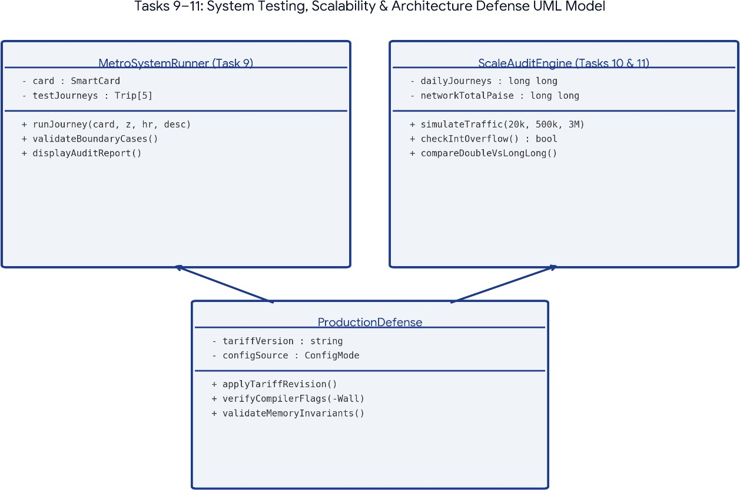

- C++
Program: #include
<iostream> using namespace std;

int main()
{
long long journeys; long long fare = 2000; long long total;

cout << "Enter Number of Journeys: "; cin >> journeys;

total = journeys * fare;

cout << "Total Amount: Rs "
<< total / 100 << endl;

return 0;
}

Output:
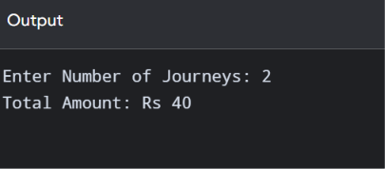
Result: The program uses long long to calculate large journey totals without a typical 32-bit integer overflow.

Pseudocode
START

DECLARE fare = 2000 paise DECLARE journeys AS LONG LONG

INPUT number of journeys

IF journeys is negative
DISPLAY "Invalid number of journeys" STOP
END IF

CALCULATE total = journeys * fare

CONVERT total paise into rupees

DISPLAY number of journeys DISPLAY total amount

STOP

Testing table

Test case | Number of journeys | Fare per journey | Expected total
1 | 1 | Rs 20 | Rs 20
2 | 100 | Rs 20 | Rs 2,000
3 | 1,000 | Rs 20 | Rs 20,000
4 | 20,000 | Rs 20 | Rs 4,00,000
5 | 5,00,000 | Rs 20 | Rs 1,00,00,000
6 | 30,00,000 | Rs 20 | Rs 6,00,00,000
7 | -5 | Rs 20 | Invalid input

Complexity
  - Time Complexity: O(1) – The program calculates the total using one multiplication operation. It does not need to calculate each journey separately.
  - Space Complexity: O(1) – Only a few variables are needed to store the number of journeys, fare, and total amount. The use of long long allows larger integer values but does not change the complexity.

Prediction Code
// Prediction code: test network-scale totals using long long #include <iostream>
using namespace std; int main() {
const long long farePaise=2000;
long long counts[]={20000,500000,3000000}; for(long long n:counts)
cout << n << " journeys = " << n*farePaise << " paise\n";
}

Prediction Output
20000 journeys = 40000000 paise\n500000 journeys = 1000000000 paise\n3000000 journeys = 6000000000 paise

Comparison – Original Assignment Code vs Prediction Code
Original Assignment Code | Prediction Code
Uses long long to store journey count. | Uses long long to test multiple large journey counts.
Uses a fixed fare of 2000 paise. | Uses the same fixed fare of 2000 paise.
Calculates total using multiplication. | Calculates and displays totals for different journey counts.
Accepts one journey count from the user. | Tests 20,000, 500,000 and 3,000,000 journeys.
Main difference: Original code calculates the total for one entered journey count, whereas prediction code tests multiple large journey counts and demonstrates why long long is required.

Alternative Code
// Alternative:

compare 32-bit int and 64-bit long long
#include <iostream> #include <limits> using namespace std; int main() {
long long total=3000000LL*2000LL;
cout << "INT_MAX: " << numeric_limits<int>::max() << '\n'; cout << "Safe total paise: " << total << '\n';
}

Alternative Output
INT_MAX: 2147483647\nSafe total paise: 6000000000

Alternative Concept: Configuration File for Fare Storage

The alternative concept stores metro fare values in an external file named fares.txt instead of writing them directly inside the C++ program. The program reads the fare values from the file using file handling. If the fare changes, the administrator can update the file without changing the C++ source code and recompiling the program. This method makes the system more flexible and easier to maintain. However, the program must check whether the file exists and contains valid fare values.

TASK 12 – Modified Metro System
- Explanation: The original metro system is modified by adding the Airport zone, weekend discount and monthly pass.
New requirements:
  - Inner = Rs 10
  - Middle = Rs 20
  - Outer = Rs 30
  - Airport = Rs 60
  - Weekend discount = 10%
  - Weekday peak surcharge = 20%
  - Monthly pass covers two selected zones. Difference between original and modified design:
Original system | Modified system
Three zones. | Four zones.
Only peak surcharge. | Peak surcharge and weekend discount.

No monthly pass. | Monthly pass added.
Basic fare calculation. | Updated fare calculation.

UML diagram:
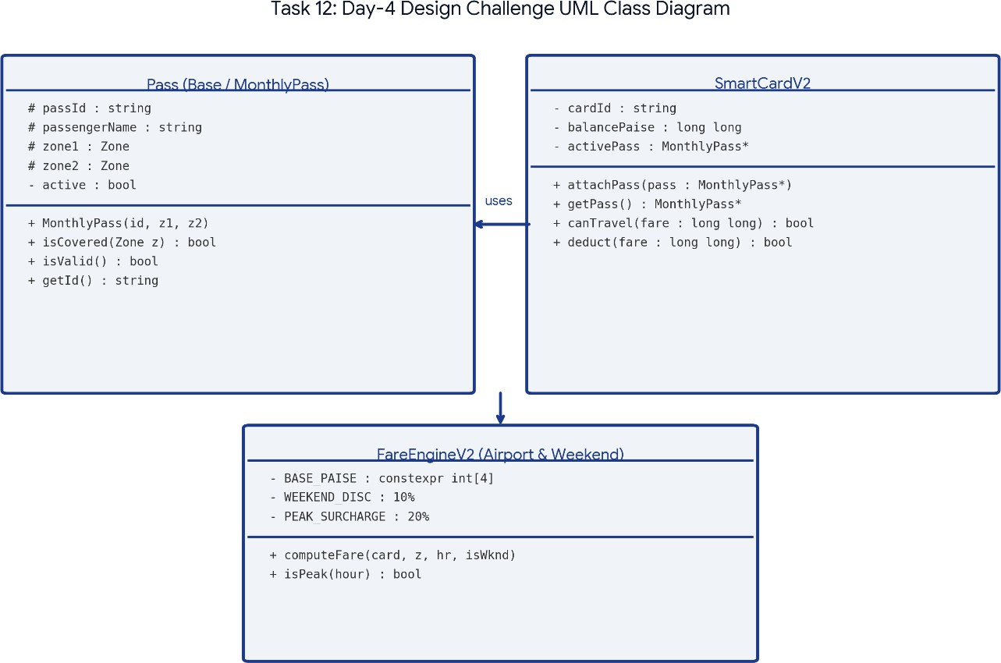

- C++ Program: #include <iostream> using namespace std;

int main()
{
int zone, hour; int fare = 0;
int balance = 20000;

int weekend, pass;

cout << "Enter Zone (1-4): "; cin >> zone;

cout << "Enter Hour: ";

cin >> hour;

cout << "Is it Weekend? (1-Yes, 0-No): "; cin >> weekend;

cout << "Do you have Monthly Pass? (1-Yes, 0-No): "; cin >> pass;

if (hour < 0 || hour > 23)
{
cout << "Invalid Hour"; return 0;
}

if (zone < 1 || zone > 4)
{
cout << "Invalid Zone"; return 0;
}

// Monthly pass covers Inner and Middle if (pass == 1 && (zone == 1 || zone == 2))
{
fare = 0;
}
else
{
if (zone == 1) fare = 1000;
else if (zone == 2) fare = 2000;
else if (zone == 3)

fare = 3000; else
fare = 6000;

if (weekend == 1)
{
fare = fare - fare * 10 / 100;
}
else
{
if ((hour >= 8 && hour < 10) || (hour >= 17 && hour < 20))
{
fare = fare + fare * 20 / 100;
}
}
}

if (balance - fare >= 5000)
{
balance = balance - fare;

cout << "Fare: Rs " << fare / 100 << endl; cout << "Journey Successful" << endl;

cout << "Remaining Balance: Rs "
<< balance / 100 << endl;
}
else
{
cout << "Insufficient Balance";
}

return 0;
}

Output:
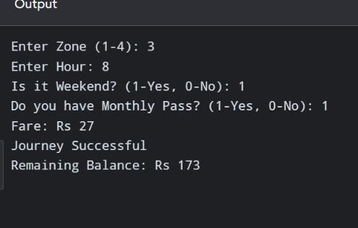
Result: The modified system calculates the Airport fare, applies the weekend discount and checks the card balance.
Note: The assignment does not specify the monthly pass price or validity. This program assumes that the pass is already active and covers Inner and Middle zones.

Pseudocode
START

DECLARE INNER_FARE = 1000 paise DECLARE MIDDLE_FARE = 2000 paise DECLARE OUTER_FARE = 3000 paise DECLARE AIRPORT_FARE = 6000 paise

DECLARE peak surcharge = 20% DECLARE weekend discount = 10%

INPUT zone INPUT travel time

INPUT day type
INPUT monthly pass status INPUT card balance

SELECT fare according to zone

IF zone is invalid DISPLAY "Invalid zone" STOP
END IF

IF monthly pass is active AND selected zone is covered SET fare = 0
ELSE
IF day is weekend REDUCE fare by 10%
ELSE IF time is peak hour INCREASE fare by 20%
END IF END IF

CALCULATE remaining balance

IF remaining balance is less than Rs 50 DISPLAY "Insufficient balance"
ELSE
DEDUCT fare from balance DISPLAY final fare DISPLAY remaining balance
END IF

STOP

Testing table

Test case | Zone | Day / Time | Pass status | Expected fare
1 | Inner | Weekday, off-peak | No | Rs 10
2 | Middle | Weekday, 09:00 | No | Rs 24
3 | Outer | Weekend, off-peak | No | Rs 27
4 | Airport | Weekday, 18:00 | No | Rs 72
5 | Airport | Weekend, 18:00 | No | Rs 54
6 | Middle | Weekend | No | Rs 18
7 | Inner | Weekday | Active, covered | Rs 0
8 | Middle | Weekday | Active, covered | Rs 0
9 | Outer | Weekday | Active, not covered | Rs 30
10 | Airport | Weekday, off-peak | No | Rs 60
11 | Invalid | Weekday | No | Invalid zone

Assumptions: The monthly pass covers Inner and Middle zones. Weekend discount takes priority over peak surcharge, so the two are not combined. The Rs 50 minimum remaining balance rule is retained.
- Complexity
  - Time Complexity: O(1) – The program selects one fare, checks the pass, applies the appropriate discount or surcharge, and checks the balance. All operations take a fixed amount of time.
  - Space Complexity: O(1) – Only a fixed number of variables are required for the zone, time, day, pass status, fare, and balance.
- Alternative Concept: Fare Table and Monthly Pass Class

The alternative concept uses an array to store fares for all four zones and a separate Pass class to manage monthly pass details. The Pass class checks whether the selected zone is covered by the monthly pass. If the zone is covered, the fare becomes zero. Otherwise, the program calculates the normal fare and applies either the weekend discount or weekday peak surcharge. The weekend discount is not combined with the peak surcharge. This design separates fare selection from pass checking, making the modified metro system easier to understand, extend and maintain.

- Prediction Code #include <iostream> using namespace std;

int main()

{

int zone, hour; int fare = 0;
int balance = 20000;

int weekend, pass;

cout << "Enter Zone (1-4): "; cin >> zone;

cout << "Enter Hour: "; cin >> hour;

cout << "Is it Weekend? (1-Yes, 0-No): "; cin >> weekend;

cout << "Do you have Monthly Pass? (1-Yes, 0-No): "; cin >> pass;

if (hour < 0 || hour > 23)

{

cout << "Invalid Hour"; return 0;
}

if (zone < 1 || zone > 4)

{

cout << "Invalid Zone"; return 0;
}

if (pass == 1 && (zone == 1 || zone == 2))

{

fare = 0;

}

else

{

if (zone == 1) fare = 1000;
else if (zone == 2) fare = 2000;
else if (zone == 3) fare = 3000;
else
fare = 6000;

if (weekend == 1)

{

fare = fare - fare * 10 / 100;

}

else

{

if ((hour >= 8 && hour < 10) || (hour >= 17 && hour < 20))

{

fare = fare + fare * 20 / 100;

}

}

}

if (balance - fare >= 5000)

{

balance = balance - fare;

cout << "Fare: Rs " << fare / 100 << endl; cout << "Journey Successful" << endl;

cout << "Remaining Balance: Rs "

<< balance / 100 << endl;

}

else

{

cout << "Insufficient Balance";

}

return 0;

}

Prediction Output

For the following inputs:

  - Zone = 4 (Airport)
  - Hour = 18
  - Weekend = 0 (No)
  - Monthly Pass = 0 (No)

Enter Zone (1-4): 4

Enter Hour: 18

Is it Weekend? (1-Yes, 0-No): 0

Do you have Monthly Pass? (1-Yes, 0-No): 0 Fare: Rs 72
Journey Successful Remaining Balance: Rs 128 Calculation
Airport fare = Rs 60. Peak surcharge = 20%.
Final fare = Rs 60 + Rs 12 = Rs 72.
Remaining balance = Rs 200 − Rs 72 = Rs 128.

Alternative Code – Using a Fare Table and Pass Class

#include <iostream> using namespace std;

constexpr int FARE[] = {1000, 2000, 3000, 6000};

class Pass

{

public:

int zone1 = 1; int zone2 = 2;

bool covers(int zone)

{

return zone == zone1 || zone == zone2;

}

};

int calculateFare(int zone, int hour, bool weekend, Pass p)

{

if (zone < 1 || zone > 4) return -1;

if (p.covers(zone)) return 0;

int fare = FARE[zone - 1];

if (weekend)

fare = fare - fare * 10 / 100;

else if ((hour >= 8 && hour < 10) || (hour >= 17 && hour < 20))
fare = fare + fare * 20 / 100;

return fare;

}

int main()

{

int balance = 20000; Pass monthlyPass;

int fare1 = calculateFare(4, 18, true, monthlyPass); balance -= fare1;

cout << "Airport Weekend Fare: Rs "

<< fare1 / 100 << endl;

cout << "Remaining Balance: Rs "

<< balance / 100 << endl;

int fare2 = calculateFare(4, 18, false, monthlyPass); balance -= fare2;

cout << "Airport Weekday Peak Fare: Rs "

<< fare2 / 100 << endl;

cout << "Remaining Balance: Rs "

<< balance / 100 << endl;

int fare3 = calculateFare(2, 11, false, monthlyPass); balance -= fare3;

cout << "Middle Zone Pass Fare: Rs "

<< fare3 / 100 << endl;

cout << "Remaining Balance: Rs "

<< balance / 100 << endl;

return 0;

}

Alternative Output

Airport Weekend Fare: Rs 54 Remaining Balance: Rs 146 Airport Weekday Peak Fare: Rs 72 Remaining Balance: Rs 74
Middle Zone Pass Fare: Rs 0 Remaining Balance: Rs 74

Comparison
  - The original program uses multiple if-else statements to select the fare for four zones.
  - The alternative program uses a fare array to store all four zone fares.
  - The original program checks the monthly pass directly using zone conditions.
  - The alternative program uses a separate Pass class to check whether a zone is covered.
  - Both programs apply the 10% weekend discount and 20% weekday peak surcharge.
  - The weekend discount is applied instead of the peak surcharge, so both are not combined.
  - The alternative design makes it easier to change the two zones covered by the pass.
  - Both designs take O(1) time for one fare calculation and use O(1) space for the fixed number of zones and pass details.
  - The alternative design is easier to extend and maintain, so modifying the original design is a suitable choice.

Operation | Time complexity | Space complexity
Fare calculation | O(1) | O(1)
Balance checking | O(1) | O(1)
Fare deduction | O(1) | O(1)
Processing multiple journeys | O(n) | O(1) additional space when processed one at a time
Storing journey records | O(n) | O(n)

Overall Conclusion

The City Metro Smart-Card System is developed using basic C++ programming concepts. It uses variables, constants, data types, operators, control statements, functions, classes and objects.
The system calculates fares based on zones and travel time. It also checks the card balance before allowing a journey. In the final task, the system is modified by adding an Airport zone, weekend discount and monthly pass.
The project demonstrates how C++ can be used to develop a simple and useful metro fare management system.
Github link: https://github.com//Sadhana143909/DSA0117_192565042_Assignment1

